Grade 7 Accelerated · Unit 3 · Thread A · Day 2  Negative Exponents with Variable Bases  Independent Set 3.T2 ANSWER KEY | Name  Date  Period

Six questions, on your own, in silence. Show the step that does the work.
1. Rewrite using only positive exponents. 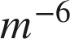
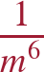

2. Rewrite using only positive exponents. 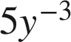

The 5 stays upstairs.

3. Rewrite using only positive exponents. 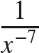

The factor moves up.

4. Simplify. Use positive exponents only. 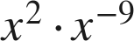

2 + (−9) = −7.

5. Simplify. Use positive exponents only. 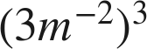
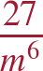
The 3 is cubed as well.

6. Find the value of . 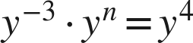
n = 7
−3 + n = 4.

